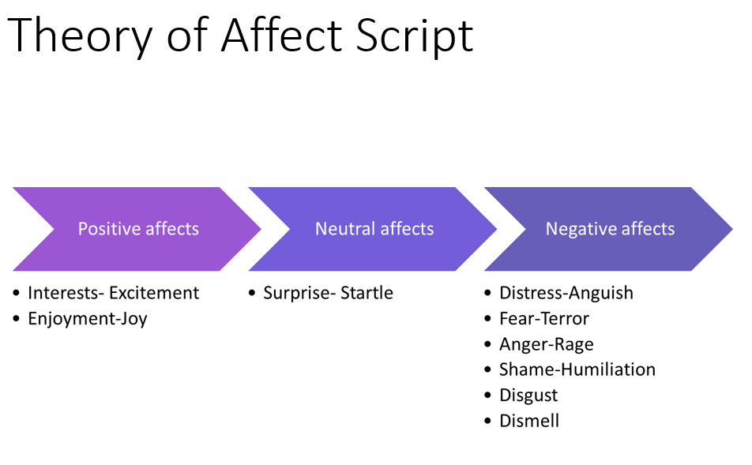

Tompkins' Theory of Affect Script:
Sylvan Tompkins, an American psychologist, proposed the theory of affect script, which posits that human emotions are organised around scripts or scenarios that guide our understanding of, and response to emotional experiences. These affect scripts are learned through socialisation and experiences, and they shape our emotional responses to various situations. Affect scripts can be positive or negative, and they influence our behaviours, decision-making, and social interactions. By understanding an individual's affect scripts, support strategies can be tailored to help the person navigate their emotional experiences more effectively.

The concept of Psychological shame
In psychological terms, shame is a complex and powerful emotion that arises when an individual perceives themselves as flawed, inadequate, or unworthy in some way. It is important to differentiate this concept of shame from the common use of the word, which often refers to feelings of embarrassment or discomfort.

Psychological shame goes beyond mere embarrassment; it involves a deep sense of self-criticism and self-condemnation. People experiencing shame often feel exposed, vulnerable, and fundamentally flawed, leading to a desire to hide or withdraw from social situations. This emotion can be triggered by real or imagined transgressions, as well as by the fear of being judged or rejected by others.

Shame can have a significant impact on an individual's mental health, self-esteem, and interpersonal relationships. It can lead to feelings of isolation, depression, and anxiety, as well as contribute to maladaptive coping strategies such as self-harm or substance abuse. Understanding the psychological concept of shame is essential for developing effective interventions and support strategies to help individuals manage and overcome this emotion.

The Central Executive
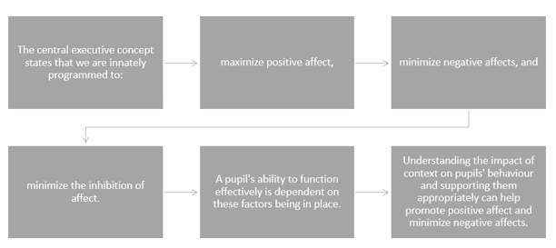

Nathanson's Compass of Shame:
Donald Nathanson, an American psychiatrist, expanded on Tompkins' affect theory by developing the concept of the’ compass of shame’. This model describes four common ways in which individuals respond to feelings of shame: withdrawal, avoidance, attack self, and attack others. According to Nathanson, these responses represent maladaptive coping mechanisms that individuals employ to manage their shame. By identifying and understanding a person's shame responses, interventions can be developed to promote healthier ways of coping with and addressing feelings of shame, ultimately improving their emotional well-being and social functioning.

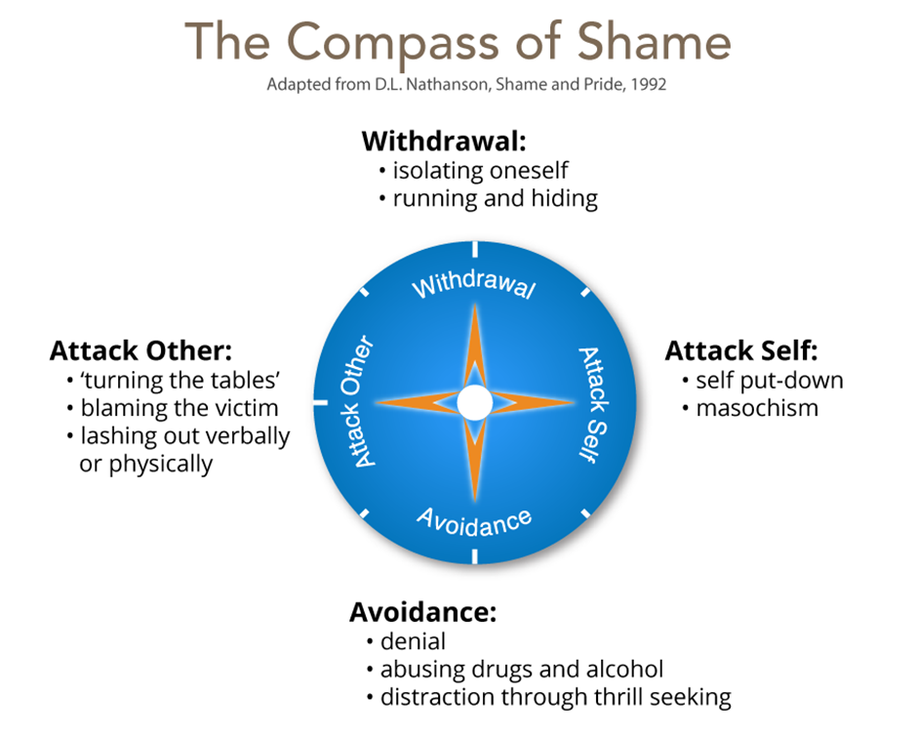

The Role of Context and Biography in presenting behaviour

